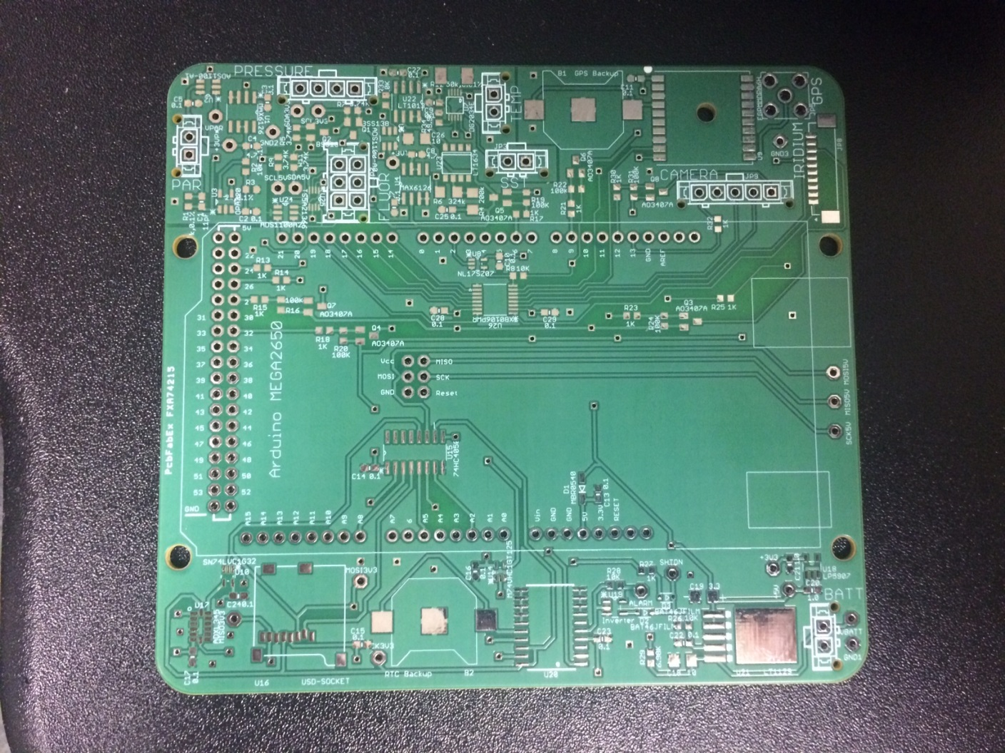

Male Headers

Male Headers

Male Headers

2x3 Female Header